# Networking Lab 0 Encapsulation and Wireshark

Wireshark is an open-source network analyzer. It copies the network traffic through your computer’s Network Interface Card (NIC) and displays the traffic for analysis. In this lab, we will use it to show how data is encapsulated according to the TCP/IP or OSI 7 Layer Model.

## Preparation

Read Wireshark_Intro_v7.0.pdf and follow the procedures it gives, to learn, install, and open Wireshark.

## Encapsulation

First, let’s get a packet to analyze. Start a capture in Wireshark. You will see that your computer is receiving a lot of traffic (and generating some) without you doing anything on your computer. This background traffic is mostly comprised of broadcasts from other computers announcing their existence and advertising services. At this point we are not interested in the broadcast traffic, but it demonstrates our first problem. There is *a lot* of traffic, and we will have to work to separate traffic of interest from all the noise.

Wireshark uses two primary filtering methods: Capture Filters and Display Filters. Capture Filters filter the traffic as it is being recorded, which reduces the amount of data that Wireshark saves. Traffic that does not pass the filter is not kept in Wireshark and cannot be displayed. Display filters do not affect what is being recorded, but only what is shown on the display. For the time being, we will just use Display Filters.

### Find the packet we want with Wireshark Display Filters

We will start by looking at an HTTP request for a web page. It should look like “GET / HTTP1.1”. It says we are looking for a web page (GET) at the root, or beginning ( / ), of the site, and we are using HTTP version 1.1.

1. Open Wireshark and a web browser if they are not open already.
2. Start a new packet capture in Wireshark.
3. In your web browser, open a site that you like that uses HTTP, not HTTPS. If you are having trouble finding an HTTP site, <http://example.com>, <http://neverssl.com>, or <http://gaia.cs.umass.edu/wireshark-labs/INTRO-wireshark-file1.html> will work.
4. Stop the packet capture when the site finishes loading. If you look at the Wireshark screen, you will see that is full of stuff that does not interest you. 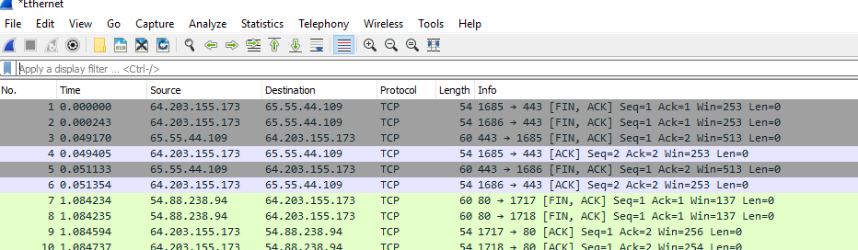
5. Type http in the display filter window. This is better, as the request is probably at the top of the list.  
   Graphical user interface

   Description automatically generated
6. Just to show that display filters can be more specific, change http to http.request in the display filter window. I have found the http.request filter to be very helpful when I am trying to track the sequence of web pages that led a user to malware.

Ugh. SSDP is a discovery protocol that uses multicast to see what it can find on the local network. We can make that go away by adding && !(ssdp) to our filter.  
http.request && !(ssdp)

### Use the Wireshark Details Panel to see encapsulation

1. Highlight the GET / HTTP1.1 packet and look at the Details Pane. Compare what you see with the Encapsulation picture on slide 5 and 7 of CyberAces_Module2-Networking-IntroAndLayer1.pdf. Ignore Layer 5 (Session) and Layer 6 (Presentation), as they are seldom/never used. Note that the section called Frame on the Wireshark Details Pane is data added by Wireshark for bookkeeping. It is not part of the packet. Graphical user interface, application, table, Word, Excel

   Description automatically generated  
   The section labeled Ethernet II is layer 2 (data link), Internet Protocol Version 4 is layer 3 (network), Transmission Control Protocol is Layer 4 (transport) , and Hypertext Transfer Protocol is layer 7 (application.) One of the things I like about Wireshark is that it makes it very easy for you to see the various layers.
2. Click the Hypertext Transfer Protocol (where the abbreviation “HTTP” comes from) to open it. The is the Application Layer of your packet, the data that was sent to the web server. You will probably see that a great deal of information went along with your request. For example, your browser tells the server what browser and operating system you are using, your language, what file types it can accept, etc. It makes your browsing experience better, but also helps web sites track you.   
   Graphical user interface, text, application, email

   Description automatically generated
3. Find the sections in your Wireshark display that correspond to the remaining layers, Transport, Network, and Data Link (Physical is your cable, NIC, etc, so it won’t appear in Wireshark.) It shouldn’t be hard, as they are in order.

## Hand In

Fill in some of the information from your packet below the drawing. For the Data Link layer, just put the source and destination MAC addresses (look like xx:xx:xx:xx:xx:xx). For the Network layer, put the source and destination IP addresses (xxx.xxx.xxx.xxx), and for the Transport layer put the source and destination port numbers. For the Application layer data, GET / HTTP1.1 is fine for the source and 200 OK for the destination.

|  |  |  |  |  |
| --- | --- | --- | --- | --- |
| Layer | 2: Data Link | 3: Network | 4: Transport (TCP) | 7: Application |
|  | MAC address | IP address | Port | Data |
| Source |  |  |  |  |
| Dst |  |  |  |  |